**IMPORTANT NEW CONTROLS**

Si no se encuentra movie.mp4 o no lo soporta, entonces busca movie.ogg

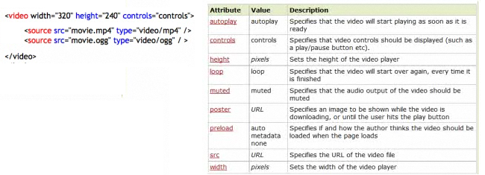

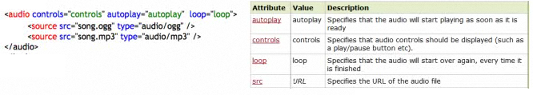

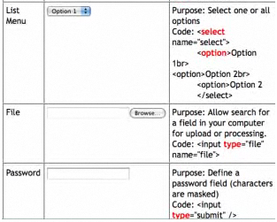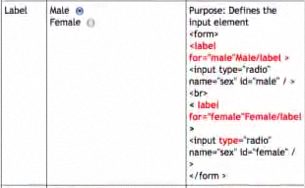

**IMPORTANT PROPERTIES**

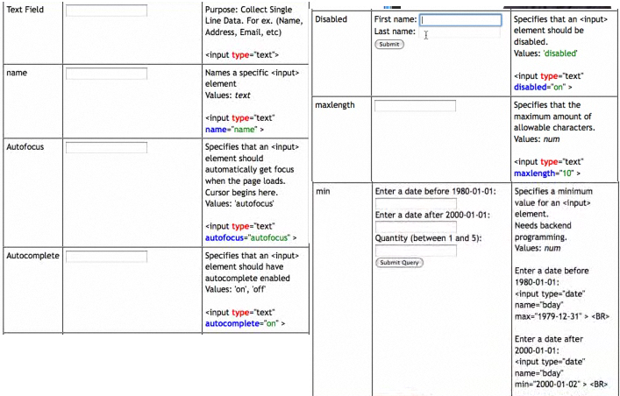

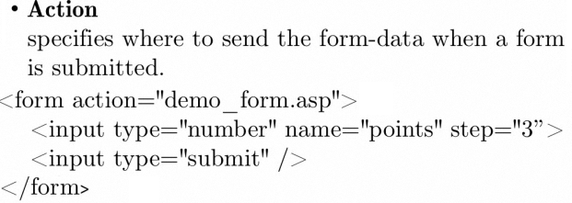

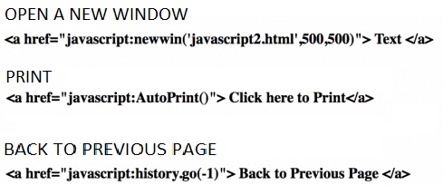

**TYPES OF WEBSITES**

- E-commerce, monetary transactions (money safety)

- Promo websites, most popular, text and images

- Database web sites, a lot of programming

- Social media, blogs

Languages of the web

* Server side: communicate from a browser to a server (JAVA, PHP, ASP)
* Client side: communicate from a browser to the client (HTLM5, CSS, JAVASCRIPT)

**Margin and Padding**

<style>

body { background-color: #CEE; }

p { background-color: #ADC;

margin: 2px ; }

padding: 2px;

border : none;

</style>

